**QUESTION 1**

**DATATYPES**

5 – Integer Data type

5.0 – Float Data type

5>1 – Relational Data type

‘5’ – Character Data type

5*2 – Arithmetic operator

‘5’*2 – Arithmetic operator

5/2 – Arithmetic operator

5%2 – Arithmetic operator

{5,2,1} – String Data type

5=3 – Assignment Operator

Pi(the number) – Integer Data type

**QUESTION 2A**

**FIND THE LETTER IN THE GIVEN STRING**

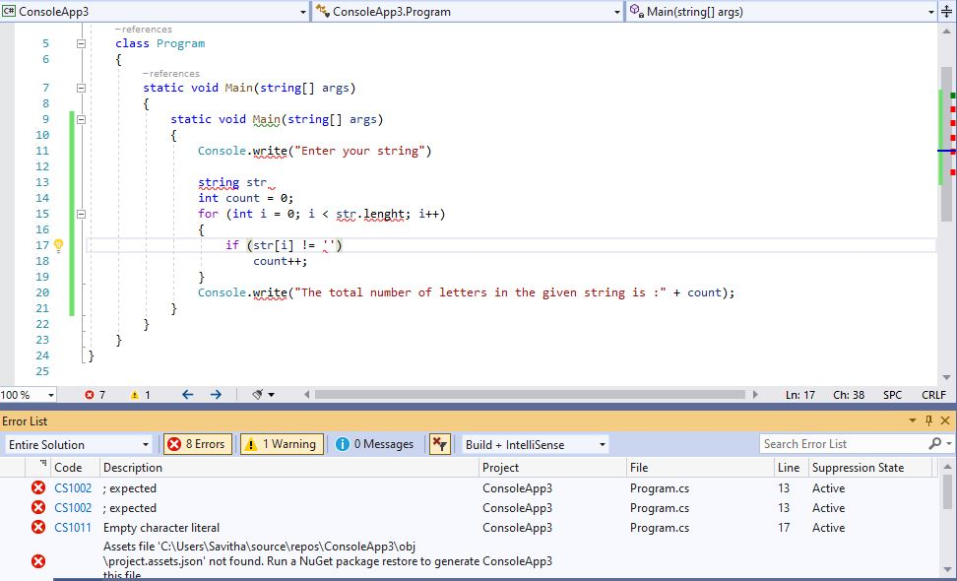

**QUESTION 2B**

**FINDING THE SUBSTRING**

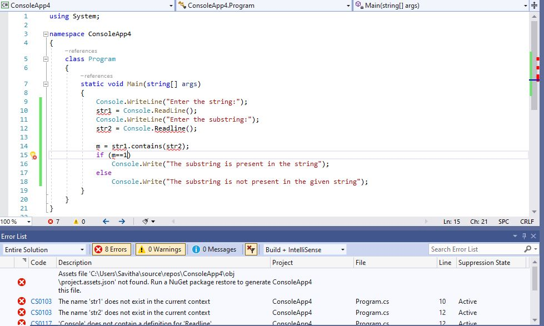

**QUESTION 2C**

**FINDING THE LONGEST STRING**

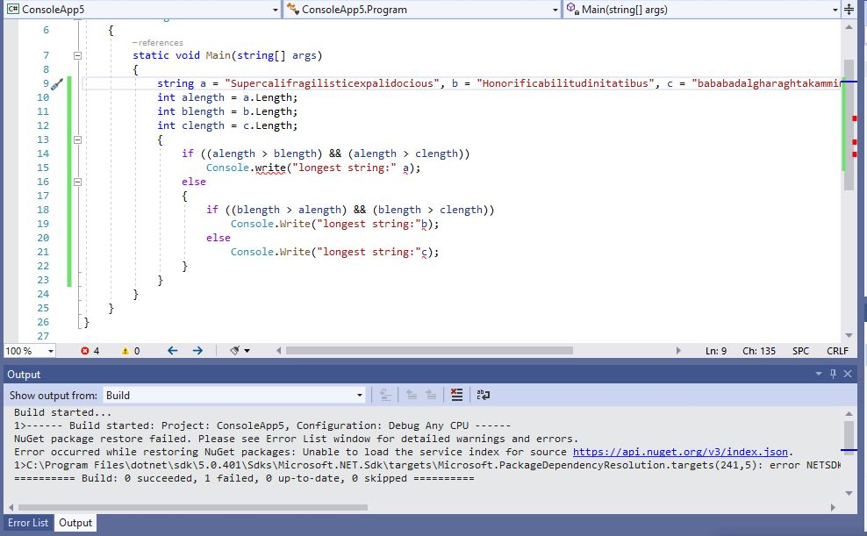

**QUESTION 2D**

**SORTING THE WORDS**

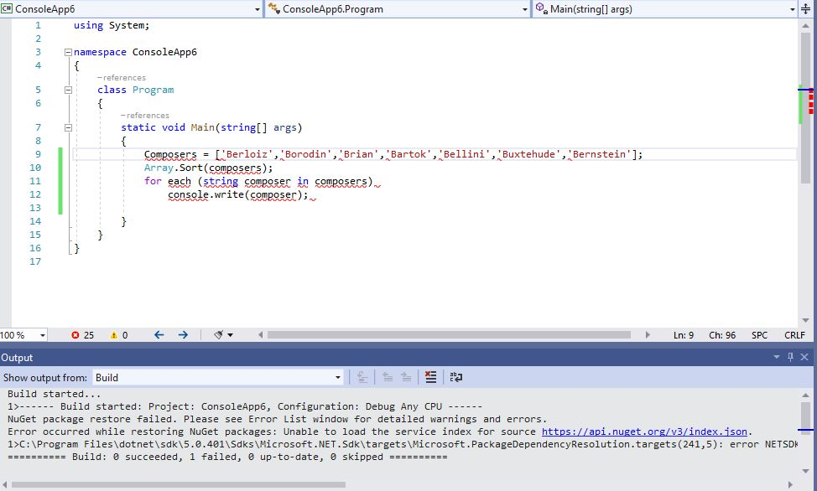

**QUESTION 3**

**FINDING THE AREA OF TRIANGLE**

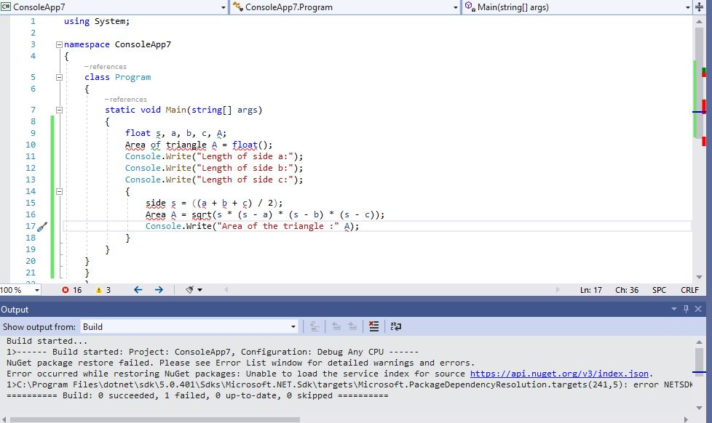

**QUESTION 4**

**FINDING ODD AND EVEN NUMBERS**

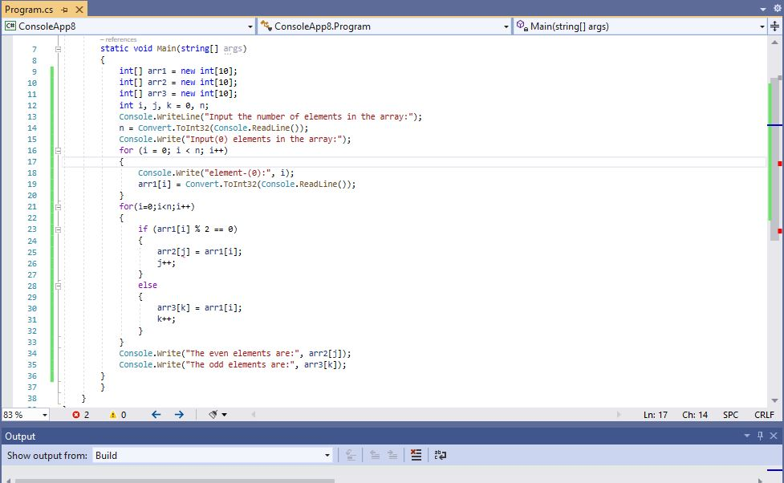

**QUESTION 5**

**FINDING SIDES OF RECTANGLE**

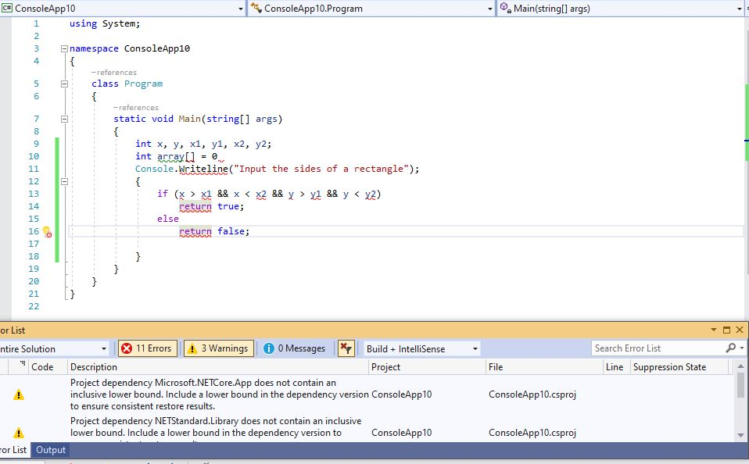

**QUESTION 6**

**PIG-LATIN WORD**

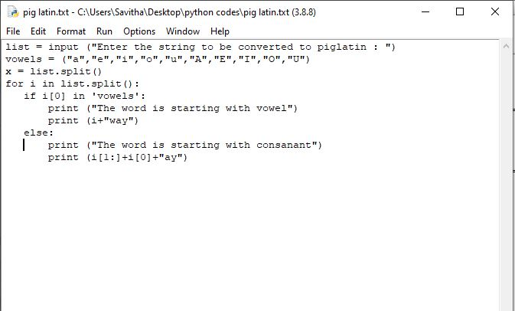

**OUTPUT**

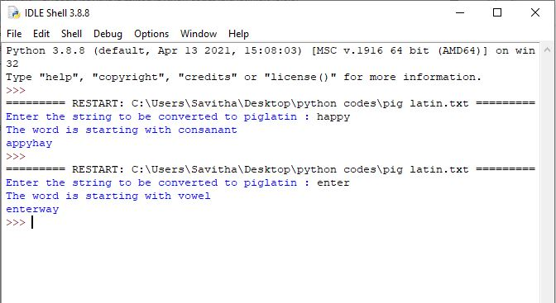

**QUESTION 7**

**FIND THE BLOODTYPES**

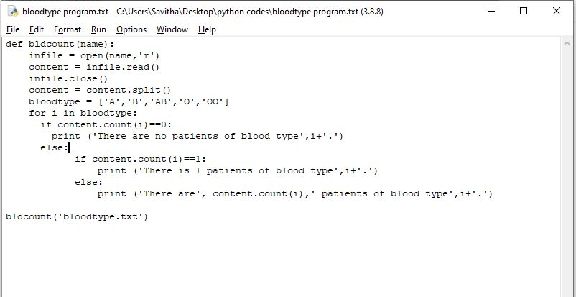

**QUESTION 8**

**CALCULATE CURRENCY**

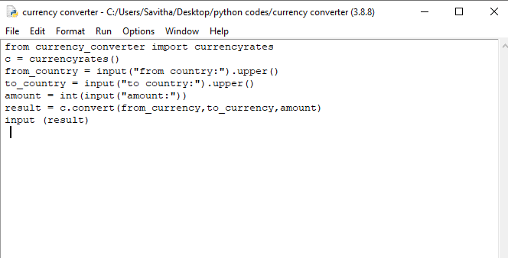

**QUESTION 9**

1. Syntax error
2. Index error
3. Index error
4. Syntax error
5. Name error